Name:_______________________________________________________
Date:________________________________________________________
Block:________________
Solving Equations Study Guide: It’s a Balancing Act!
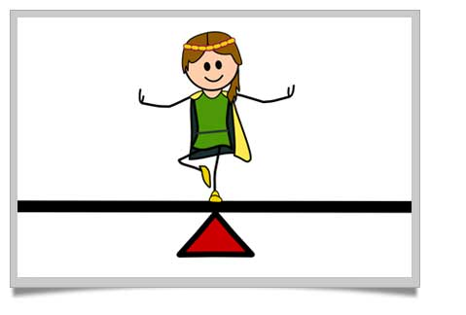
Your number one goal when solving an equation is to isolate the variable, which means to get it all alone on one side of the equal sign. To do this, you need to use inverse operations. Just remember to keep the equation balanced—so whatever you do to one side you MUST do the same thing to the other side. Keep it balanced. Keep it equal.
Your next quiz will focus on evaluating expressions, input/output tables, and solving addition and subtraction equations.
Inverse Operations are operations that undo each other. This means they are opposites.
Let’s review using Inverse Operations

Addition
x + 77 = 115 77 is added to x.
−77 = −77 Subtract 77 from both sides to
x = 38 undo the addition.

Check: x + 77 =? 115
38 + 77 =? 115 Substitute 38 for x in the equation.
115 = 115 38 is the solution.

Subtraction
k − 14 = 35 14 is subtracted from k.
+14 +14 Add 14 to both sides to undo the
k = 49 subtraction.

Check: k − 14 =? 35
49 − 14 =? 35 Substitute 49 for k in the equation.
35 = 35 49 is the solution.

1.  t + 31 = 50 | 2.  m – 13 = 42 | 3.  $$14+p=24$$ | 4.  b - 18 = 27

Let’s Try Some Together. You must also show that you plugged your answer back in to check.
Time to try some on your own! Be sure to show the inverse operations and how you isolate the variable. You must also show that you plugged your answer back in to check.
1.  t + 61 = 80  Check: | 2.  n – 15 = 52  Check: | 3.  k – 25 = 150  Check: | 4.  18 + b = 27  Check:
5.  h - 93 = 84  Check: | 6.  q + 9 =16  Check: | 7.  52 + w = 68  Check: | 8.  y - 38 = 24  Check:
Modeling Balancing Equations
1 | 1 | 1 | 1 | 1 | 1 | 1 | 1 | 1 | 1
1 | 1 | 1 | 1 | 1 | 1 | 1 | 1 | 1 | 1

Watch the teacher’s demonstration for how to balance equations and then you’ll be ready to model some on your own!

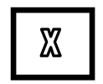
Algebra Tiles:

