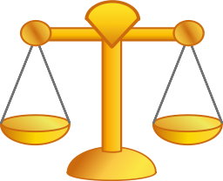Name:_______________________________________________________

Date:________________________________________________________

Block:________________

Solving Equations Study Guide: *It’s a Balancing Act!*

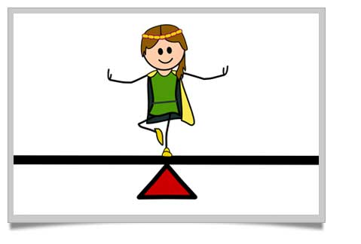**🖢Your number one goal when solving an equation is to isolate the variable, which means to get it all alone on one side of the equal sign. To do this, you need to use inverse operations. Just remember to keep the equation balanced—so whatever you do to one side you MUST do the same thing to the other side. Keep it balanced. Keep it equal.**

**🟊** *Your* ***next quiz*** *will focus on evaluating expressions, input/output tables, and solving multiplication and division equations.*

**🟊** *Let’s review using* ***Inverse Operations***

Multiplication

15t  75

t is multiplied by 15

Divide both sides by 15 to undo the multiplication.

t  5

**🟊Inverse Operations** are operations that undo each other. This means they are **opposites**.

Check: 15t ? 75  
 15(5) ? 75 Substitute 5 for t in the equation.

75  75 ✓ 5 is the solution.

Division

 8 a is divided by 12.

12 •  8 • 12 Multiply both sides by 12 to undo the division.

a  96

Check:  ? 8

 ? 8 Substitute 96 for a in the equation

|  |  |  |  |
| --- | --- | --- | --- |
| 1. $\frac{a}{16}$ = 10 | 2. 18b = 270 | 3. 7h = 84 | 4. $\frac{y}{8}$ = 24 |

8  8 ✓ 96 is the solution.

Let’s Try Some Together. *You must also show that you plugged your answer back in to* ***check****.****Time to try some on your own****! Be sure to show the inverse operations and how you isolate the variable. You must also show that you plugged your answer back in to* ***check****.*

|  |  |  |  |
| --- | --- | --- | --- |
| 1. $\frac{x}{15}=12$     Check: | 2.  5c= 155    Check: | 3. $$\frac{b}{17}=9$$ Check: | 4.  25y = 375  Check: |
| 5.  12n = 180  Check: | 6.  6p = 78    Check: | 7. $$\frac{e}{19}= 34$$   Check: | 8. $$\frac{v}{16}=8$$ Check: |

*Modeling Balancing Equations*

|  |  |  |  |  |  |  |  |  |  |
| --- | --- | --- | --- | --- | --- | --- | --- | --- | --- |
| **1** | **1** | **1** | **1** | **1** | **1** | **1** | **1** | **1** | **1** |
| **1** | **1** | **1** | **1** | **1** | **1** | **1** | **1** | **1** | **1** |

*Watch the teacher’s demonstration for how to balance equations and then you’ll be ready to model some on your own!*

*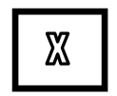Algebra Tiles:*