Name:_________________________Date:_________________Block:__

Solving Decimal Equations
When solving equations, you must use the inverse operation to help you isolate the variable and find its value. Remember, whatever you do to one side, you must do to the other. Show ALL work and CHECK your answers.

Ask yourself: Self, what operation is happening here? What is the inverse of that?

Example:
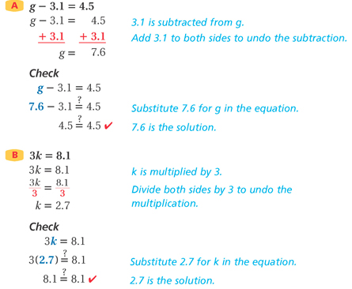

Complete these practice problems. Solve for the variable. Check your work.

1.  a – 2.3 = 4.8  Check: | 2.  8.5 = 2.49 + x  Check:
3.  6n = 8.4  Check: | 4.  $$\frac{c}{4}=3.2$$  Check:
5.  b – 5.6 = 3.7  Check: | 6.  3r = 62.4  Check:
7.  $$\frac{a}{5}=2.78$$  Check: | 8.  k + 27.45 = 69.2  Check:

