Name:_______________________________
Date:____________________
Block: _______
Chapter 3 Lesson 4: Multiplying Decimals

- When multiplying decimals, ignore the _________________ ___________________ and multiply the numbers as you normally would.
- After finding the product, go back and look at the ___________________.
- Count the number of __________________ to the right of the decimal point in the factors.
- That is how many digits that MUST be to the_________________ of the decimal point in the ___________________.

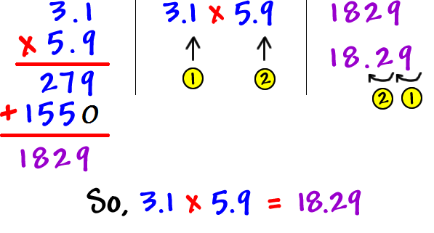
Example:

Remember-
Rewrite the problem without the decimal point or extra zeros.

Now it’s your turn

*Be ESPECIALLY CAREFUL with where you place the decimal point on these problems. You may just have to add a little something in order to get the correct answer!

0.08 0.013
x 0.06 x 0.05

